# PREPARATION AND MAINTANENCE OF ZOHO BOOKS OF ACCOUNTS FOR HEALTH HUB MEDICAL CLINIC

**(HEALTHCARE –INDUSTRY)**

# INTRODUCTION:

## Overview

HealthHub Medical Clinic, a healthcare facility, relies on Zoho Books to manage patient billing and invoicing. They can track medical service fees, manage insurance payments, and generate statements for patients. Zoho Books helps them maintain financial transparency and ensures efficient billing processes.

## Purpose

* + - Zoho One gives you accounting tools to categorize transactions, track cash flows, and monitor your financial health. Keep your accounts organized to track your assets and liabilities. Connect your bank account to automatically import transactions.
    - Zoho Books is your one-stop platform for managing your accounting tasks and organizing your transactions. It's a single secure location to keep up with your company's bills and invoices, reconcile your bank statements, control your spending, oversee projects, and eliminate GST compliance worries.

# PROBLEM DEFINITION & DESIGN THINKING:

## Empathy Map

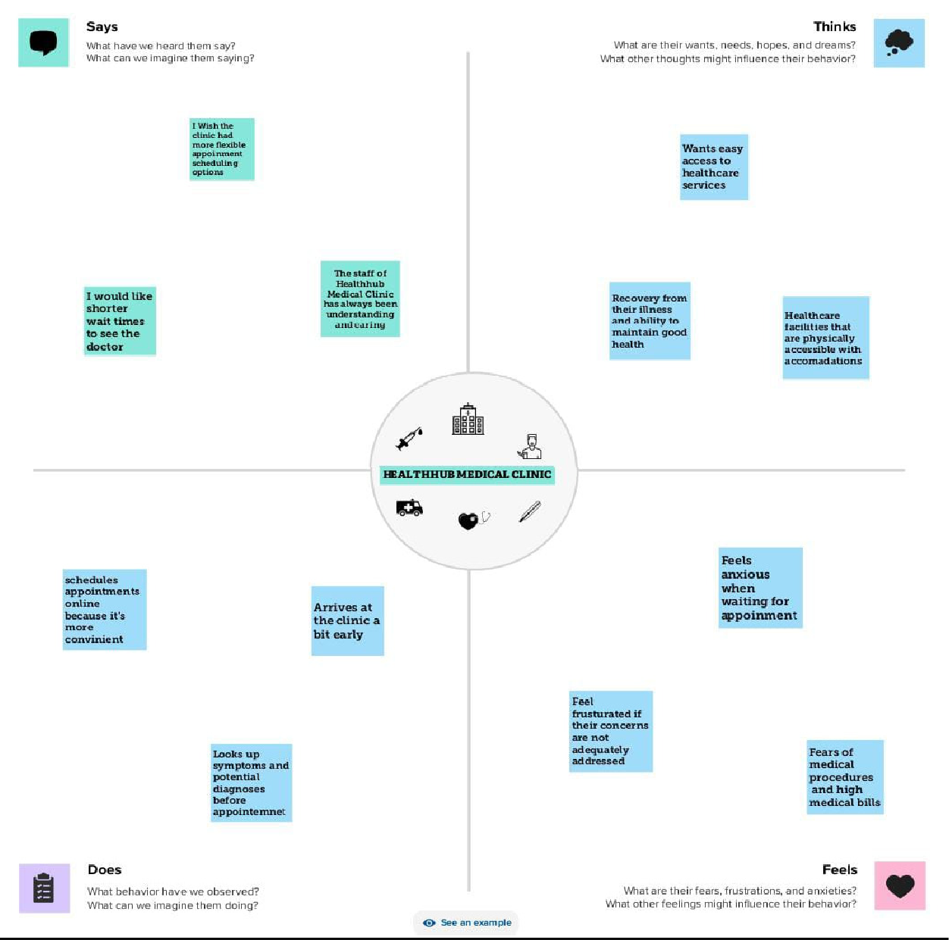

* 1. **Ideation & Brainstorming Map**

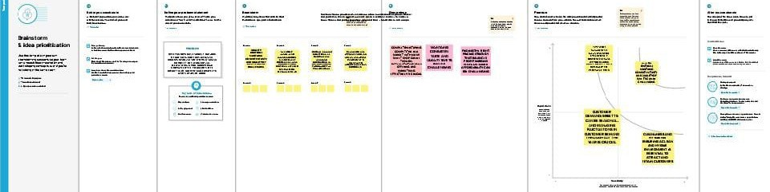

# RESULT:

## Output

The output of profit and loss for Healthhub medical clinic from 0 1/04/2023 To 30/04/2023 with the profit of rs.1,05,000.00

The balance sheet as on 08/05/2023 with the Total Assets and the Total Liabilities of rs. 2,03,000.00

# The statement of profit and loss & Balance sheet are shown as below

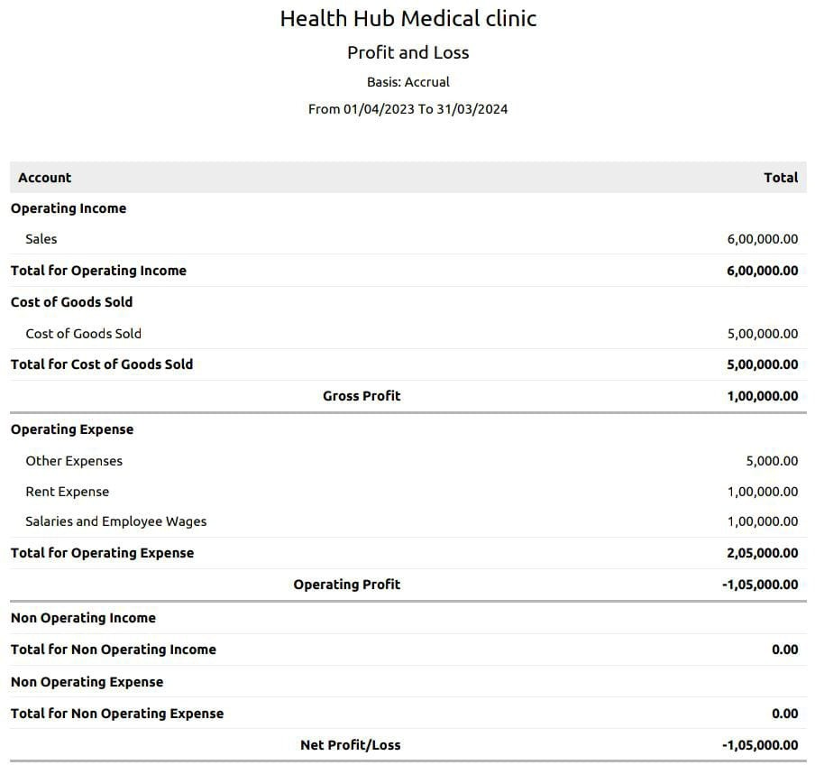

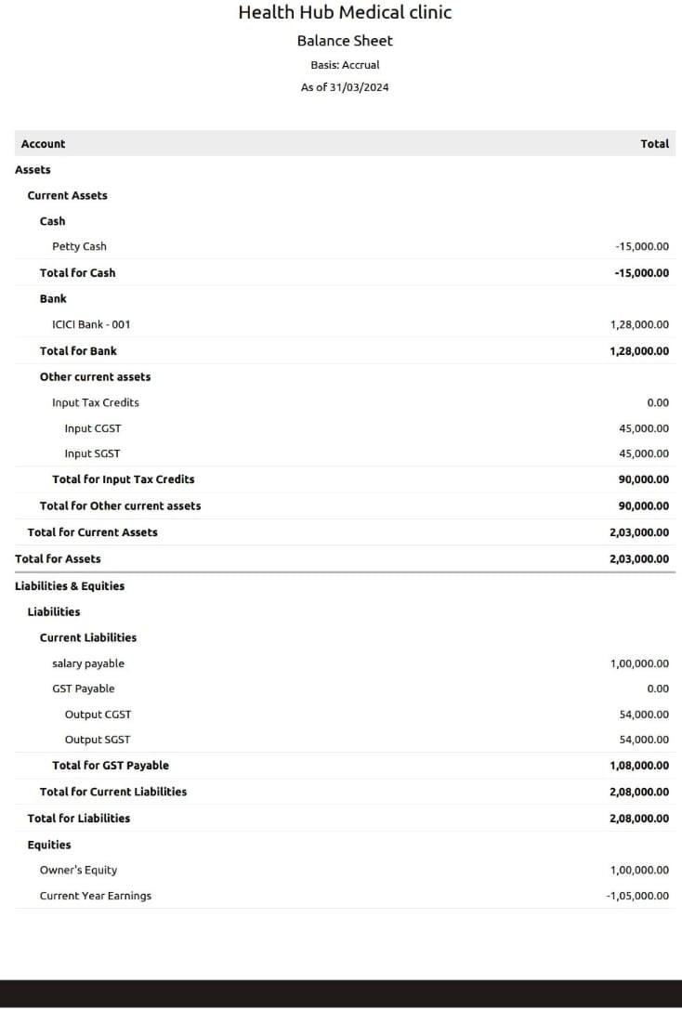

1. **ADVANTAGES& DISADVANTAGES:**

## Advantages

* Manage different aspects of hospital operations efficiently with easy access to critical patient information.
* Create easily customizable and user-friendly forms to quickly gather patient information.
* Maintain all the patient records securely with improved accessibility, and manage them all in one place.

## Disadvantages

* It does have a certain level of complexity that may not be suitable for businesses with limited technical expertise. This could impact the ease of implementation and adoption.
* All Zoho Books plans set a maximum number of invoices you can issue per year. Zoho Books also lacks features for calculating any type of tax other than sales tax.
* Difficult to balance your personal life. Full-time employment can be rigorous, requiring your full commitment for most of the week (normally 40 hours from 9 am to 5 pm).

## APPLICATIONS:

* This solutions can be applied in the areas of all healthcare industires to track medical service fees,manage insurance payments and statements of patients.

# FUTURE SCOPE:

* + It allows you to manage your projects from budgeting to logging time and invoicing customers effectively. Moreover, Zoho Books Software lets you record the time spent on tasks and avoid overbilling and underbilling your customers

# CONCLUSION:

* + Preparation and maintanence of zoho books for health hub medical clinic defines the invoicing and payments.It also maintains the financial transparency with the profit and loss accounts and balance sheet.